Instructions to Run **i-Learn**

THE APP **‘i-Learn’** IS HOSTED ON:

[**https://deepak-tiwari-ilearn.netlify.com**](https://deepak-tiwari-ilearn.netlify.com).

**User Name**: Deepak || **Password**: admin

**Other User Names are**: Purushottam || Rishi || Admin || Student

**Browsers**: **Mozilla** (preferred), Chrome

**If using Mozilla, please add the Security exception and then proceed.**

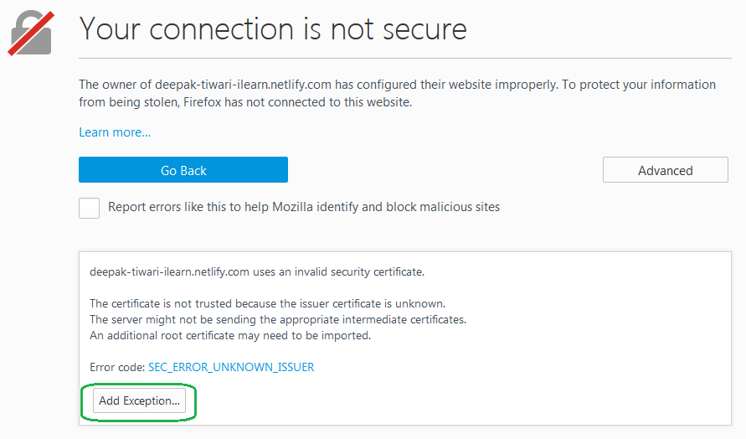

**If using Chrome please type run and paste & enter the below line. This is required for hosting**:-

chrome.exe --user-data-dir="C:/Chrome dev session" --disable-web-security)

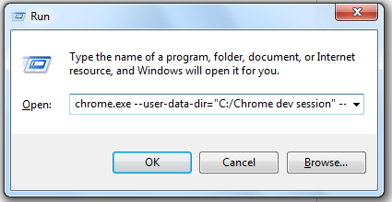



**About i-Learn**

**i-Learn** system is a capable demonstration of how the AI/ML can help improve our eLearning systems and make Learning more productive and gamified thus enhancing end user experience.

This would also mean having reduced costs being incurred by organizations in maintaining LMS systems.

iLearn demonstrates its ability to help students/associates take courses ,quizzes and it also predicts them their Learning paths ,suggests them their courses ,presents them self-created contents with most relevant score and also provides them an **‘i-Coach’** which can talk and understand associates queries and would bring them their query results. This will all add a lot of meaning to the intended audience and purpose. This system would have capability to repurpose and create learning content, providing them an **i-Mentor**, predicting their Learning paths, projecting them their achievements and profiles and would keep them update.

**How to Use**

Login to iLearn Application using the **url** and username/password provided. You may use any one of the User Name.

Now browse through the links. Launch Courses & Quizzes. Explore iMentor. At present iMentor will only capture and learn your sentiments. Since this is a prototype, it will be later build to be more responsive in terms of full length responses and data required. The data shown on dashboard is also captured basis the iMentor recording your achievements and your professional profile.

Next is Relevance Search where the iLearn system would help you with Full Length search Strings and bring you data in fractions of seconds. For prototype I have used a Wikipedia crawler which will scan nearly 85000 articles and pull their first paragraph into corpus file. Then our algo would index all data. Now when you type in Full length search string it will bring and rank you the most relevant result in blazing fast speed. Just try and see if you get some relevant results for your full text search. This will later be built into more improvised system.

Also the iMentor chat bot at present judges your sentiment and display you your sentiment. I am planning to extend this prototype into more meaningful conversation as after first step of sentiment analysis we can plan for correct responses basis some text and doc mining.

Another feature of iLearn system is Course and Quiz upload. **For using this feature you need to setup the application locally and follow the steps as mentioned below**. The Course upload module converts all PPTs into HTML5 and makes it available for viewing.

# Steps to setup the system on Local/Test/Production Environment

* Please ensure you have NodesJS ,Git installed on your system with elevated privileges.
* Please type below for NodeJS in NodeJS Command window.



* Please type below for Git in Git Bash/Command window

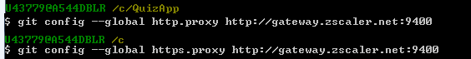

* If you are setting it up locally or on dedicated server having a dns name steps are same with only thing is that this application has two components one that is runni gon Port 8080 and other that will use port 3000 for Admin module. Also at present you need to manually trigger admin course /quiz upload as only one can run at a time on port 3000. In future plans are there to merge both into one.

## Steps to setup and run i-Learn LMS System

Step 1. Goto Git CMD/Git Bash . Run with elevated privileges.

Step 2. Type C:>git clone <https://tfs.ust-global.com/tfs/UST-Global-D3-2017/_git/iRise>

Step 3. This should create a local folder named iRise into your C: /D: Drive.

Step 4. Now type C:> cd iRise

Step 5. Now type: npm install -g http-server

Step 6. After its finished type the following c:\iRise> http-server -o

Step 7. This should display a message that Server has been started. Now you can access your

Application on http:\localhost:8080 or 8081 as listed on command window.

**User Name**: Deepak || **Password**: admin

## Steps to setup and run Admin Course Upload Utility

Step 1. This module runs on ExpressJS Node Server.

Step 2. Open another instance of Git CMD/Bash.

Step 3. Type C:\iRise\ngCourse> node Server.js

Step 4. This would run another application on http:\localhost:3000.

Step 5. Access the application. Browse to the 'artefact' folder inside iRise. Go under Course Folder

and select any zipped folder. Now click on Upload. This should display "File Uploaded".

Step 6. Now Refresh/Relogin to your iRise Application running on Port 8080/8081.

Step 7. Click 'Course' Menu on Left. You can see Thumbnail of the course uploaded.

Step 8. This demonstrated how the application converts an PPT/PPTX Zipped file to HTML 5 Format

and display it to user. You may also embed a video inside HTML5 Folder only in .**ogg** format.

**This can be done separately by course admin as Course Authoring Mechanism.**

## Steps to setup and run Admin Quiz Upload Utility

Step 1. This module runs on ExpressJS Node Server.

Step 2. Open another instance of Git CMD/Bash.

Step 3. Type C:\iRise\ngQuiz\build> node Server.js

Step 4. This would run another application on http:\localhost:3000.

Step 5. Access the application. Browse to the 'artefact' folder inside iRise. Go under Quiz Folder and

select any folder either **js/java/ng.** Please select a JSON File.

Step 6. Now click on Upload. This should display "File Uploaded".

Step 7. Now Refresh/Relogin to your iRise Application running on Port 8080/8081.

Step 8. Click 'Skills & Quizzes' Menu on Left. Click on three sections on any section.

Step 9. This demonstrated how the application uploads the Quizzes in JSON Format to the iRise

Application. You can build your own JSON Quizzes but don't forget to number them in format

'quiz_'. There is also a provision to include screen shots in your JSON uploaded but for that

you need to upload a proper image to iRise images folder and reference it in JSON.

Please Note that Admin Course and Quiz Upload Utility runs on same Port 3000. So you can use only

one at a time. For using any of the Admin Utilities, please follow the steps as listed above. The iRIse

application (without Admin functionality) is also hosted at

<https://deepak-tiwari-ilearn.netlify.com>.

**User Name**: Deepak || **Password**: admin